October is a big month at the Boston Free Library!
The Friends of the Boston Library Book Sale runs Saturday, October 10th through Saturday, October 17th during regular library hours. We are open regular hours from 10:00 AM – 7:00 PM on October 12th so if you have the day off, it’s the perfect time to come to the library! Stop in for great deals on books, DVDs, and CDs. Kids’ books are only $0.25 each. There are lots of treasures to be found!
Come paint pumpkins at the library on Thursday, October 15th! We have sessions of Painted Pumpkins for all ages at 4:00 PM and 5:30 PM. Call 716-941-3516 to register to attend so we are able to prepare enough supplies for everyone – space is limited.
Lego Club meets on Monday, October 19th at 5:30 PM with a spooky building challenge for the Halloween season.
Our Chess Club starts back up Thursday, October 22nd at 5:30 PM. All ages welcome and instruction will be provided.
For more information about any of our events, call 716-941-3516, visit our webpage https://www.buffalolib.org/locations-hours/boston-free-library, and check us out on Facebook https://www.facebook.com/BostonFreeLibrary/.

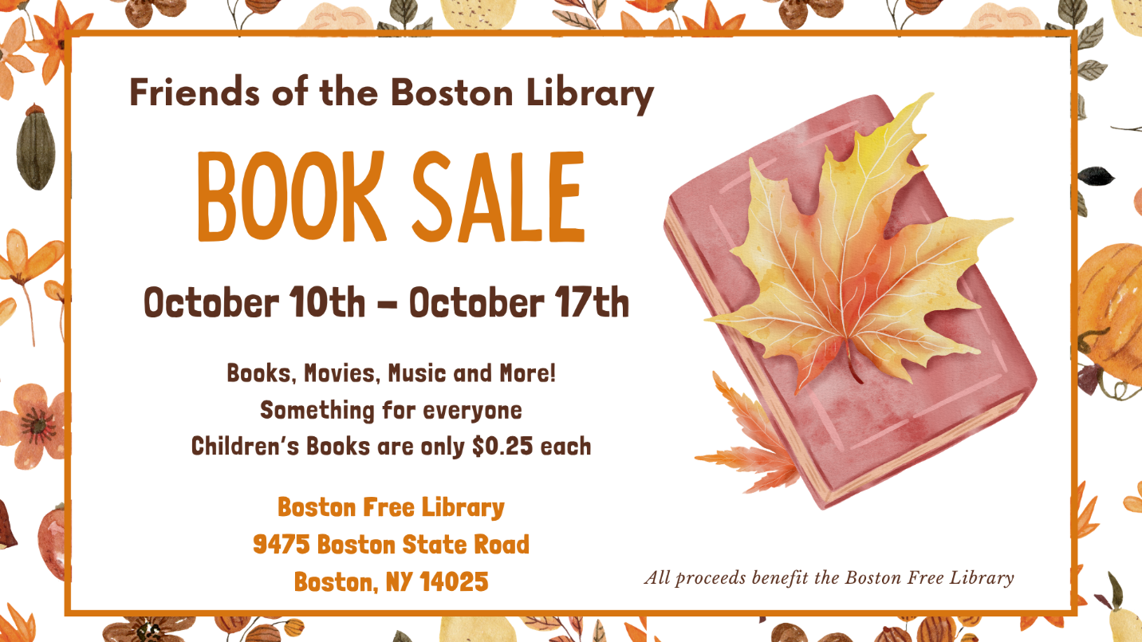

Boston Free Library
P.O. Box 200
Boston, New York 14025
(716)941-3516

